Project Design Phase-II
Problem-Solution Fit Template
DATE | 1 NOVEMBER 2025
TEAM ID | NM2025TMID05966
PROJECT NAME | STREAMLINE TICKET ASSIGNMENT FOR EFFICIENT OPERATIONS
MAXIMUM MARKS | 4 MARKS

Problem-solution fit template
- In many organizations, ticket assignment for issues or service requests is manual and time-consuming, leading to operational delays.
- Tickets are often assigned incorrectly, causing duplication, bottlenecks, and delayed resolution.
- Lack of real-time tracking and prioritization results in poor service quality and customer dissatisfaction.
- No centralized visibility of workload distribution among support agents leads to inefficiency and uneven task allocation.
- Communication gaps between departments increase resolution time and reduce accountability.
Purpose
• To develop a smart and automated ticket assignment system that enhances the efficiency of operations and reduces manual effort.
• To ensure quick and accurate ticket routing to the right support agent or department based on priority, category, and workload.
• To minimize response and resolution times, improving overall service quality and customer satisfaction.
• To provide real-time visibility into ticket status, agent performance, and workload distribution.
• To create a scalable, secure, and user-friendly platform that supports future enhancements and integration with other systems.

Template:
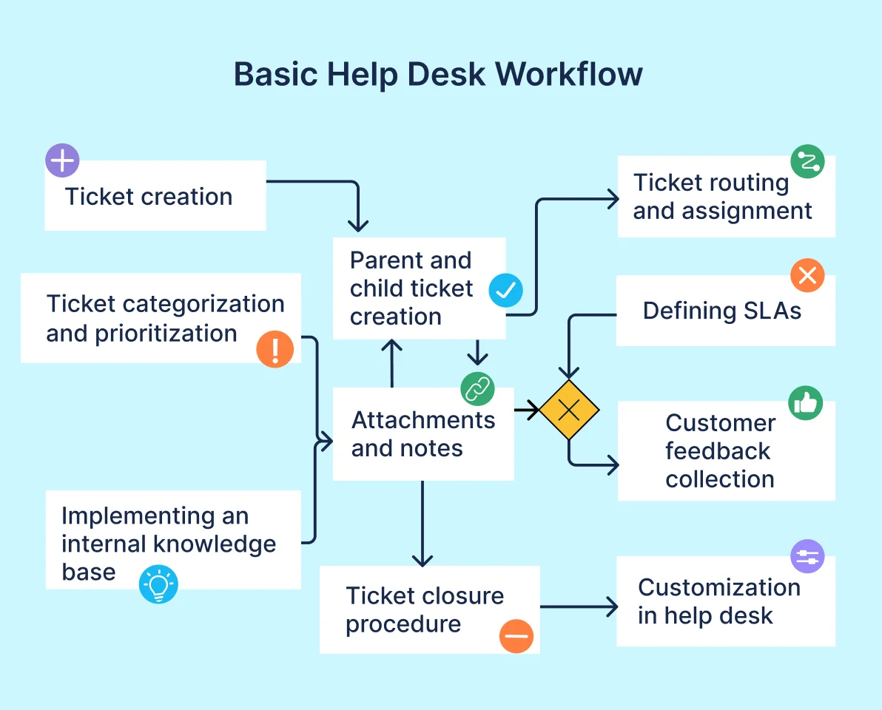
Reference:
1.https://www.ideahackers.network/problem-solution-fit-canvas/
2. https://medium.com/@epicantus/problem-solution-fit-canvas-aa3dd59cb4fe
The project “Streamline Ticket Assignment for Efficient Operations” successfully demonstrates how automation can enhance the efficiency and accuracy of service management processes. By replacing manual ticket assignment with a rule-based or AI-driven system, organizations can ensure faster response times, balanced workload distribution, and improved customer satisfaction.
The solution not only simplifies operational workflows but also provides transparency through real-time tracking and reporting. With its scalable architecture, strong security measures, and compliance with industry standards, the system is adaptable to future needs and can be integrated easily with existing platforms. Overall, this project contributes to building a more efficient, reliable, and data-driven support environment for modern organizations.

